**Project Output Screen Shots**

**1.Sporty Shoes webapp Home page**

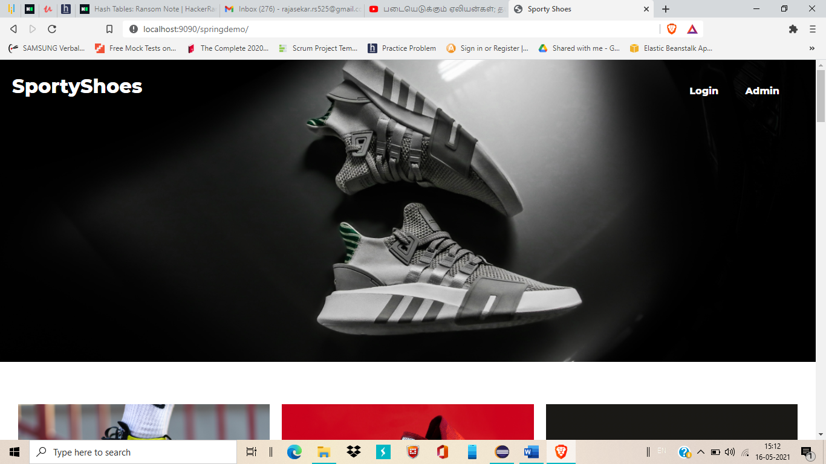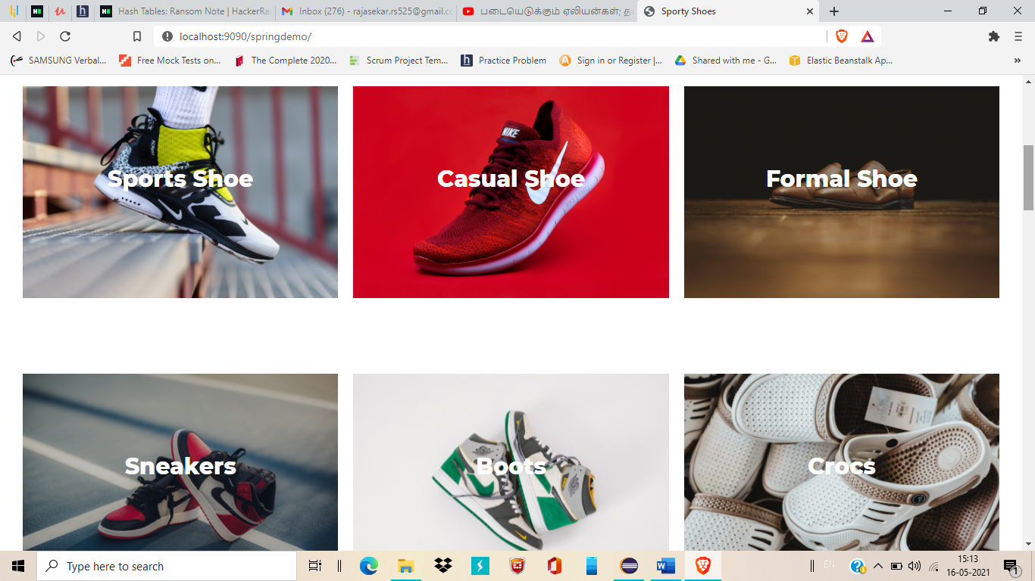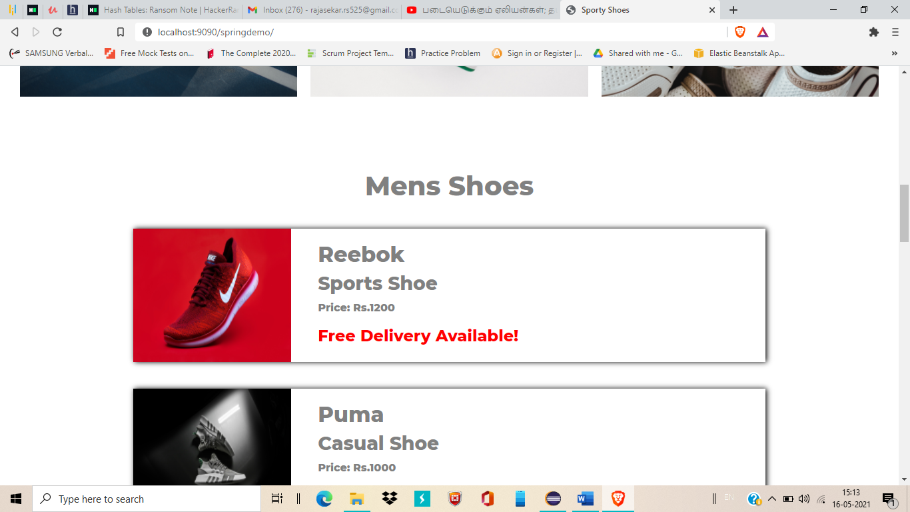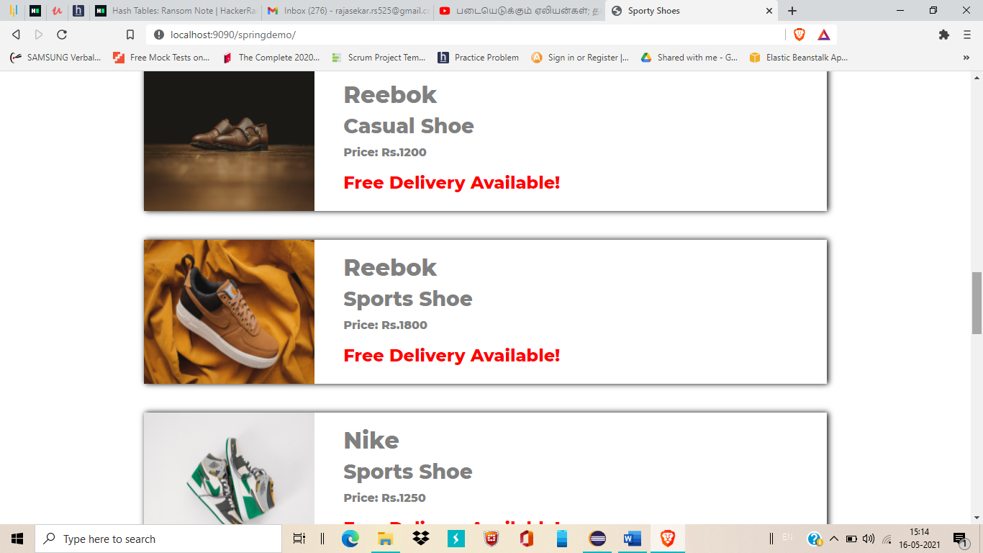

**2.Click on any one of the listed product. It redirect to Individual product page**

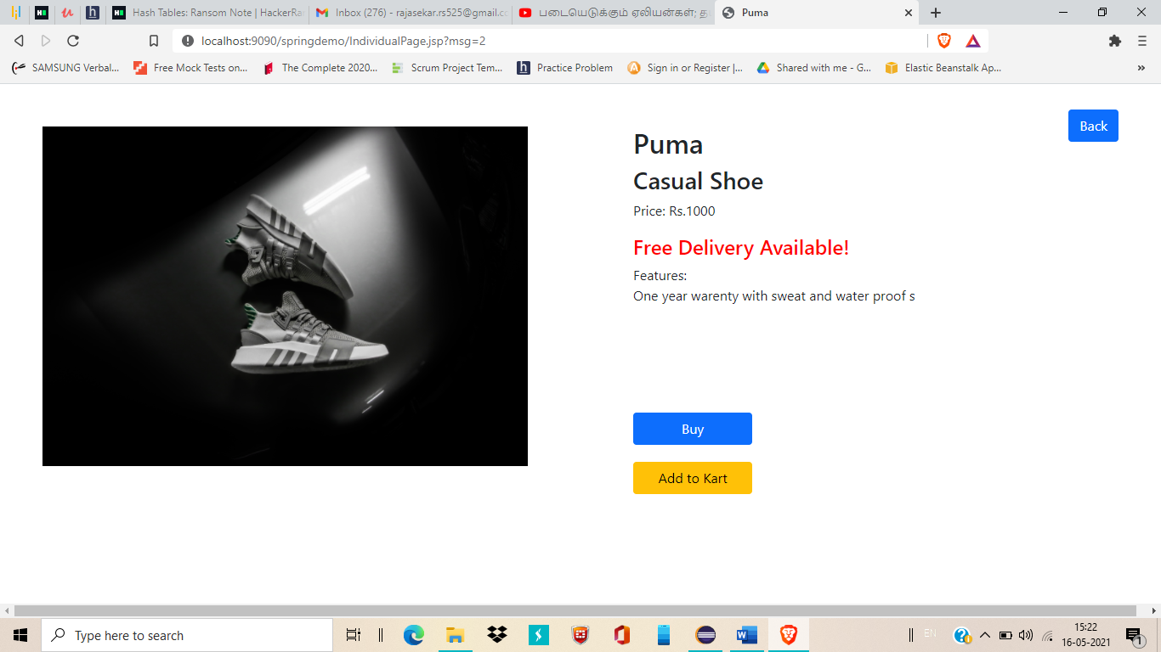

**3.You can buy the product directly but can’t able to add it to your Kart(need to login)**

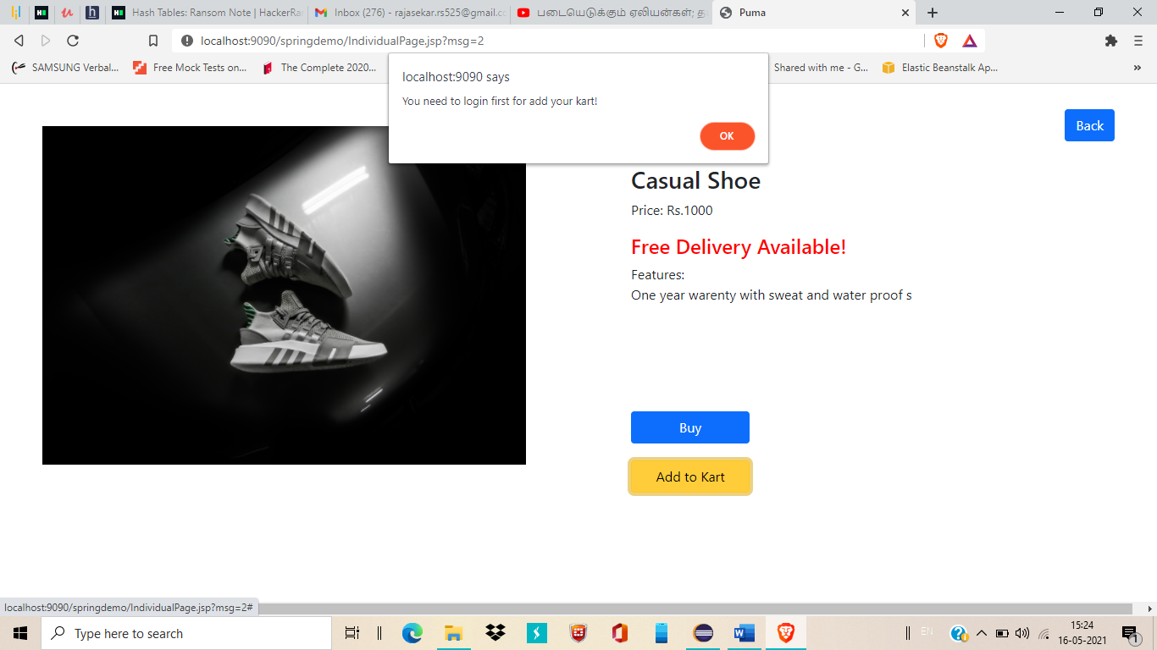

**4.Click on buy**

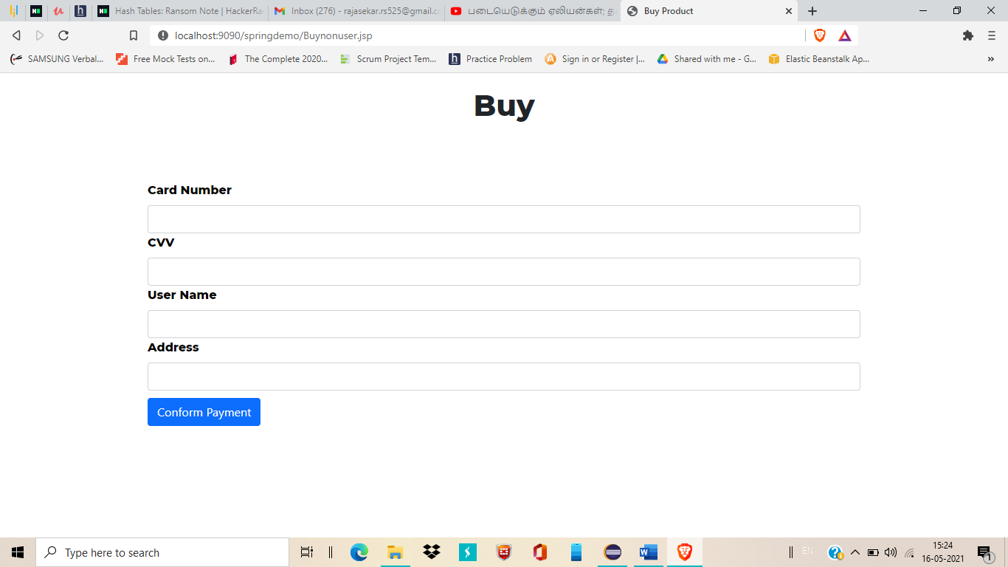

**5.Need to enter card details here then submit the payment**

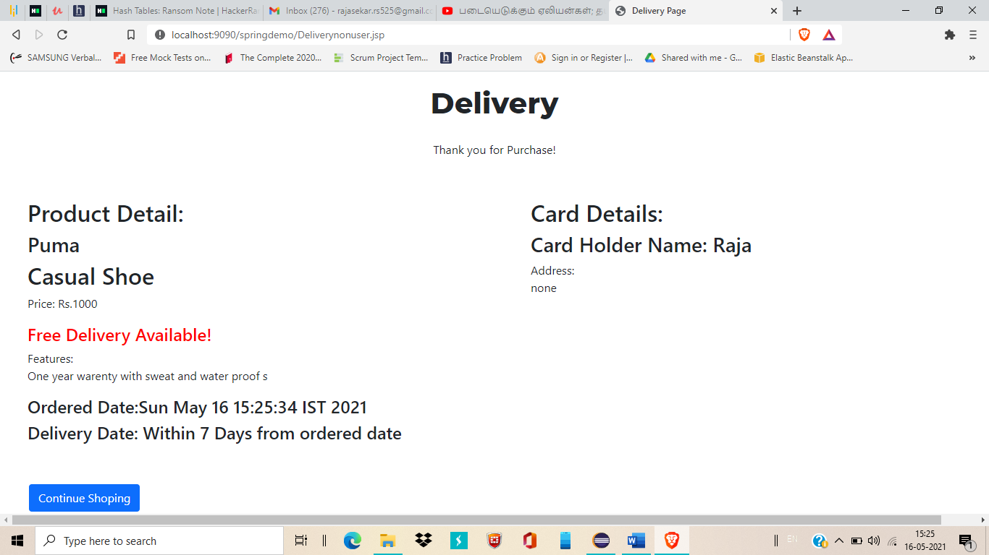

**6.You will get confirmation page and can able to return to home again by clicking**

**7.There are Two options we can see in Home page**

**. Login**

**. Admin**

**8.Click on Login Option**

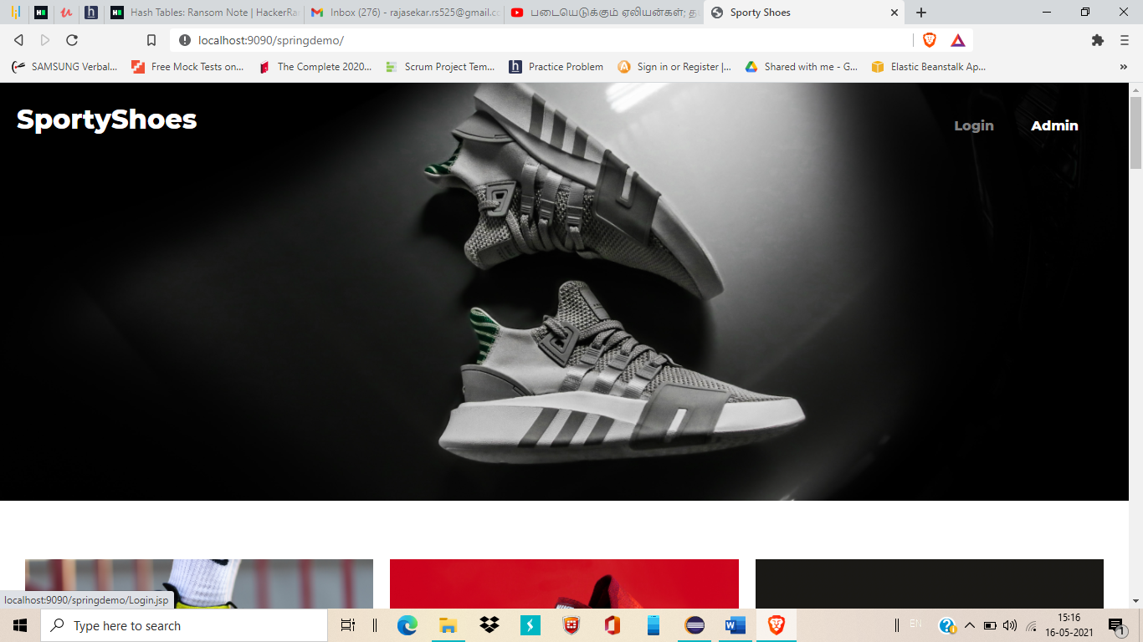

**9. Here you need to enter user login credentials**

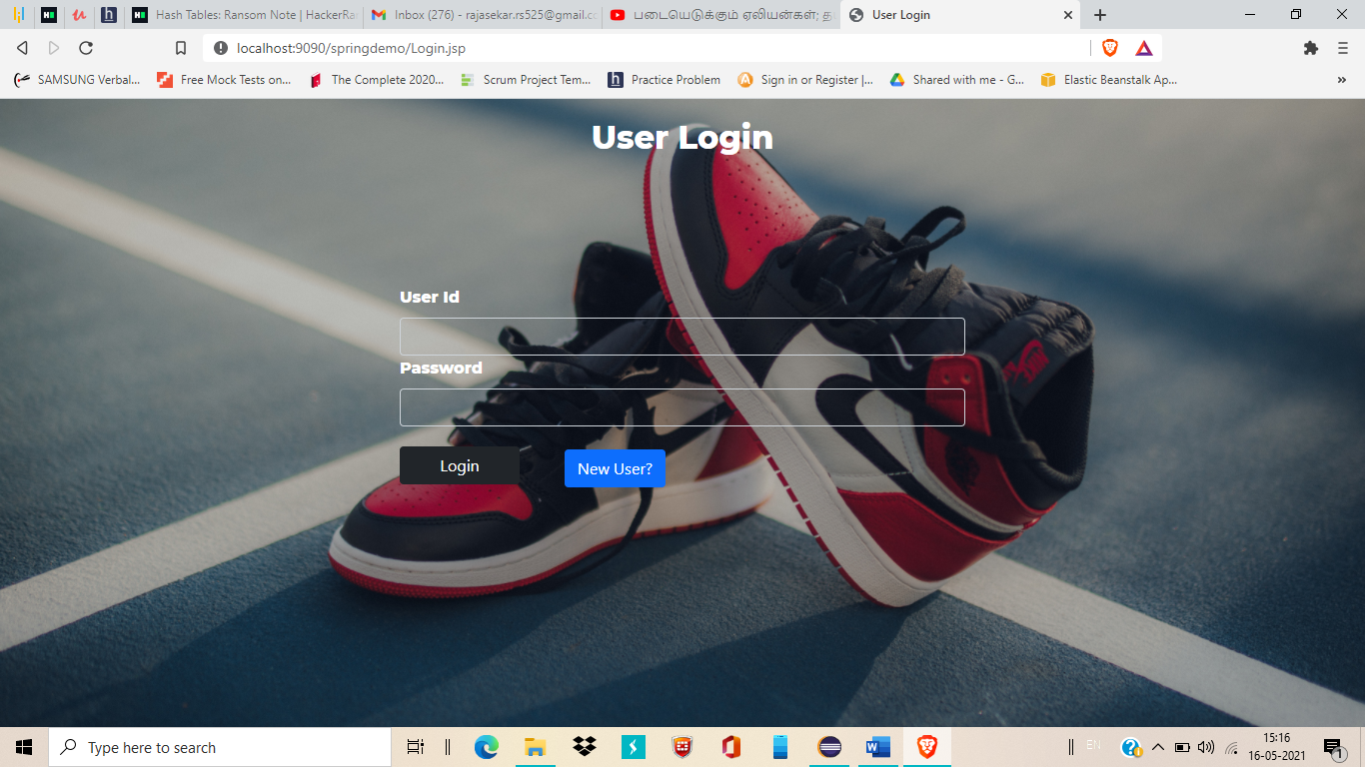

**10. If don’t have then click on new user option to register your self first**

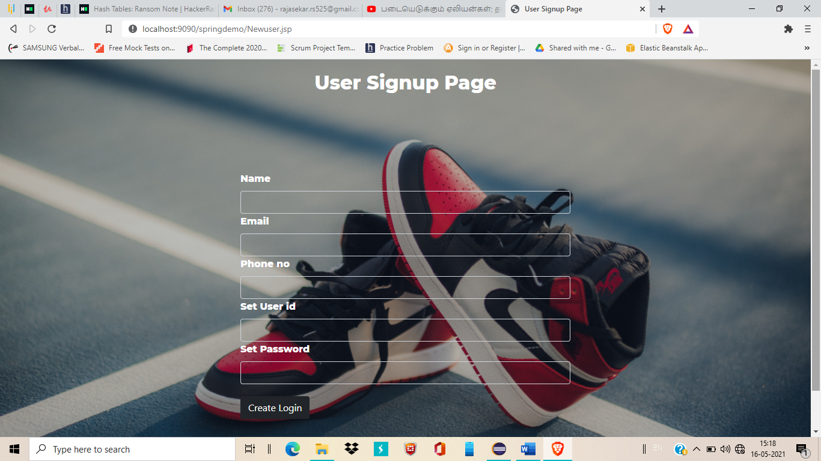

**11. After enter a credentials we can able to login to our page. This is our separate page (You can see your user id here)**

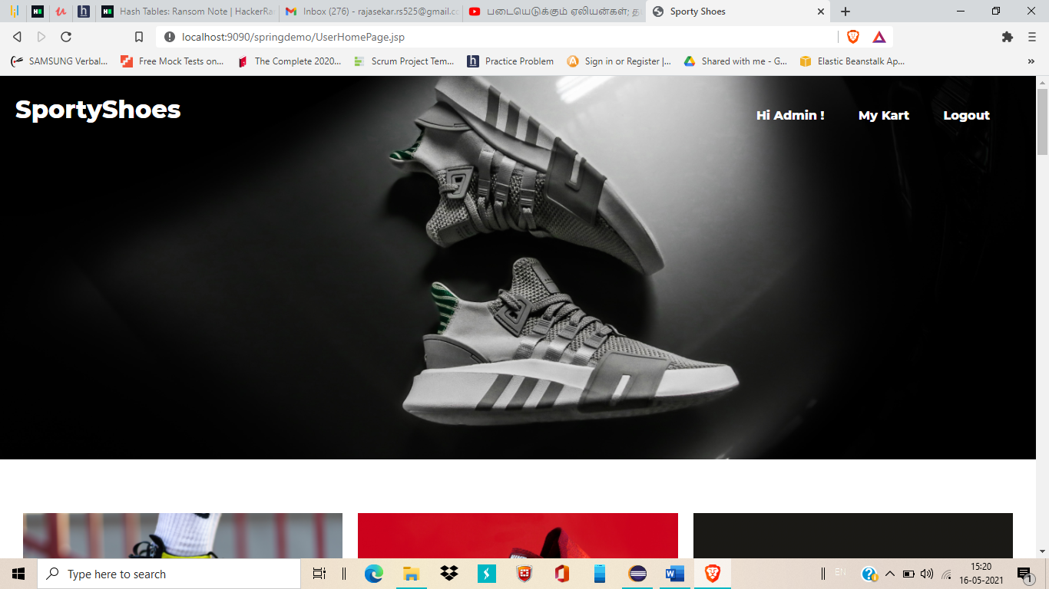

**12.Here also you can buy and you have additional benefits of add the product into your kart**

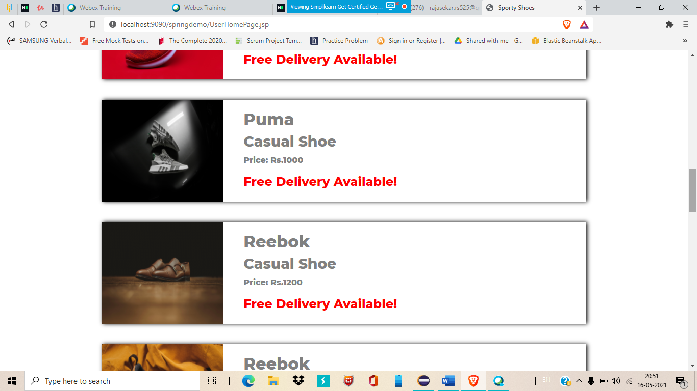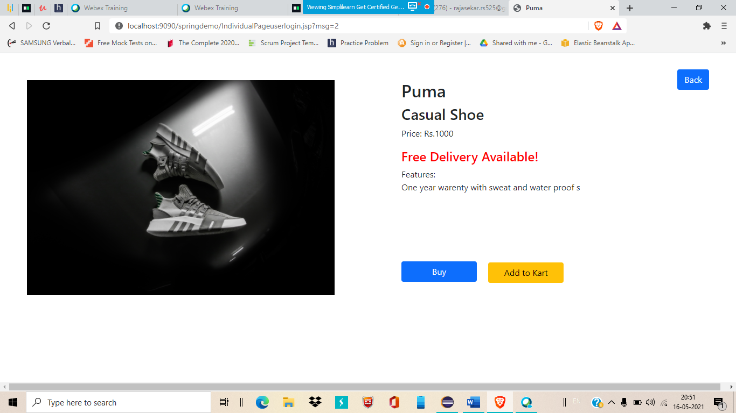

**13.Add this product into your kart by click on Add to Kart**

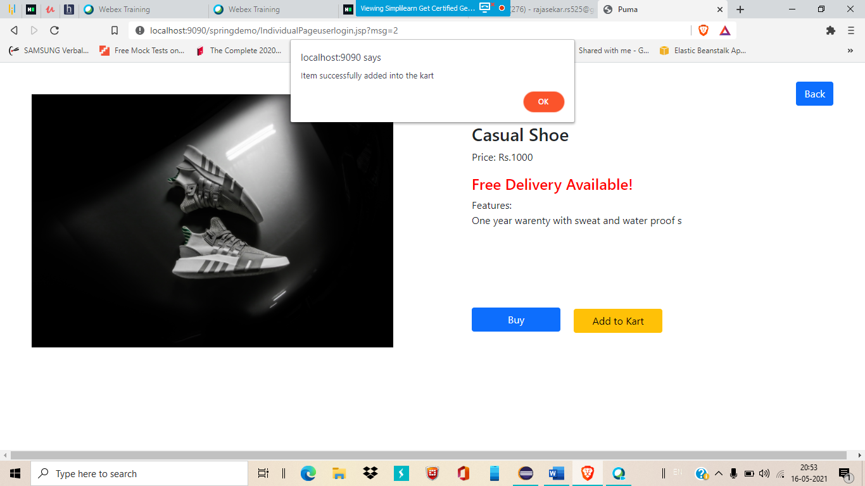

**14.You can see the alert for successfully add this product into your kart**

**Go to my kart and check whether the product is successfully added into the kart**

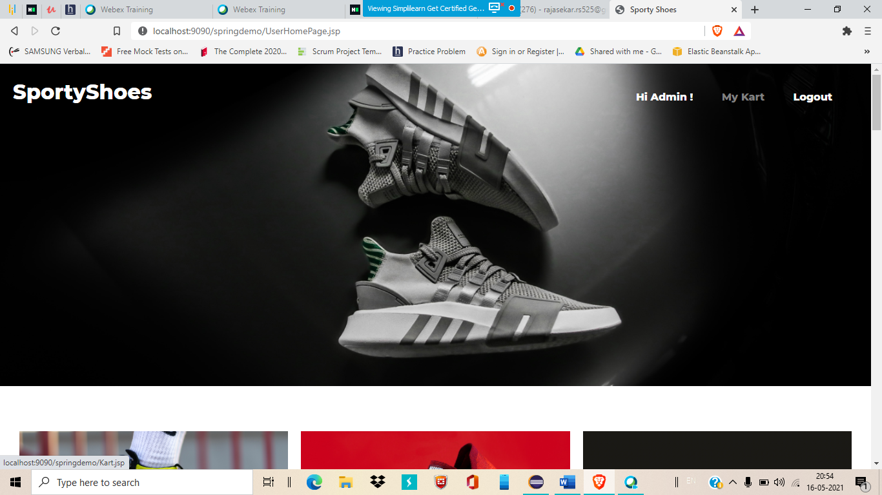

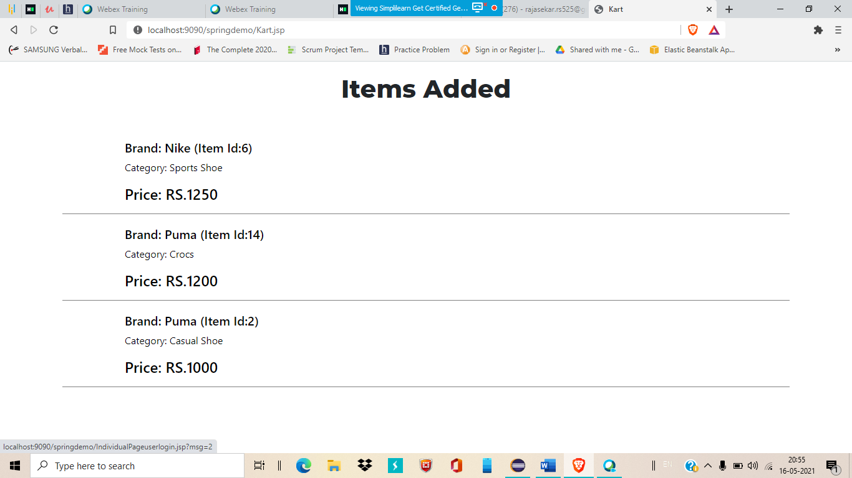

**15.Successfully get the product. By clicking on the particular product to directly go to the product like below**

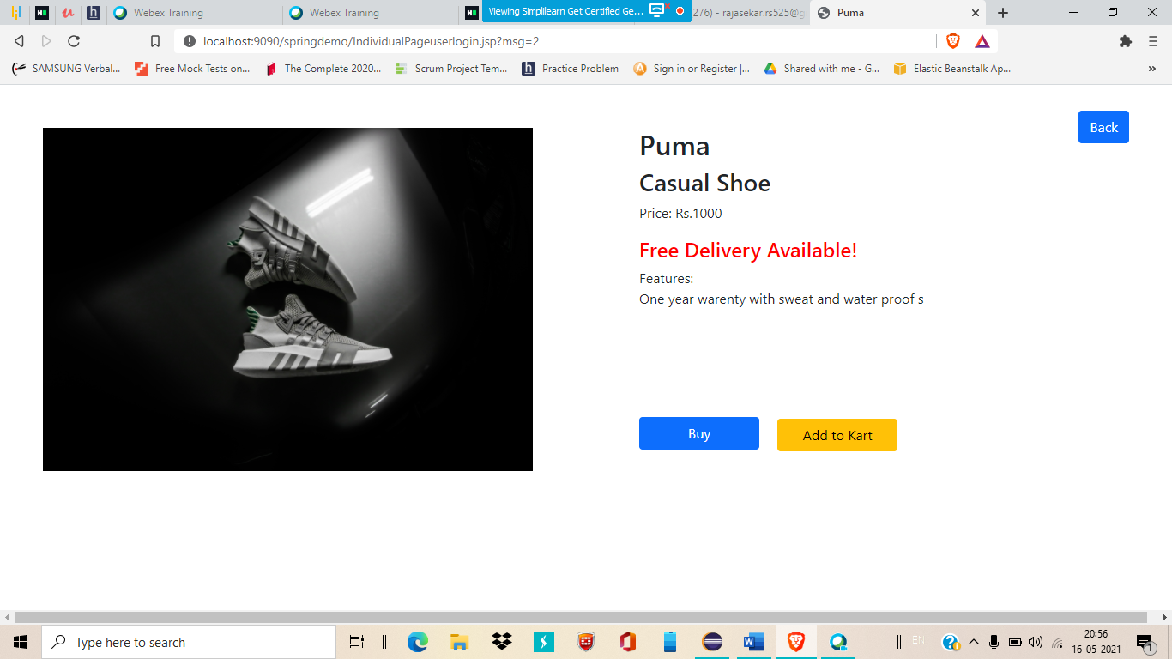

**16.Logout from User login and click on Admin button to reach out the admin login page**

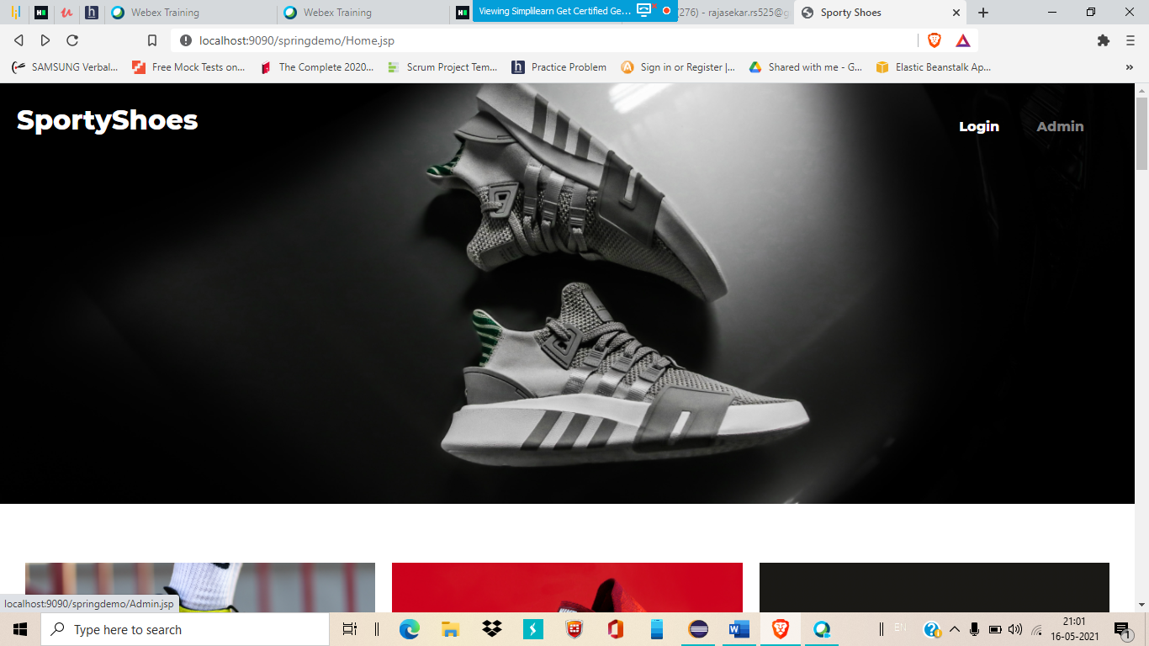

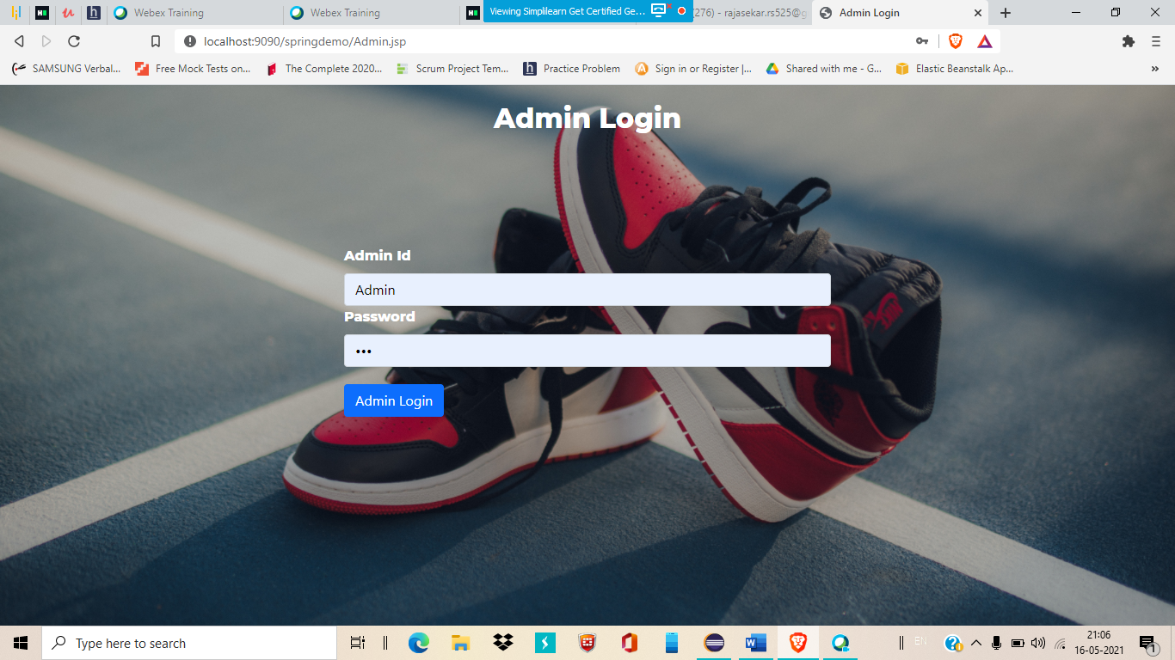

**17.Admin Home page have three major options**

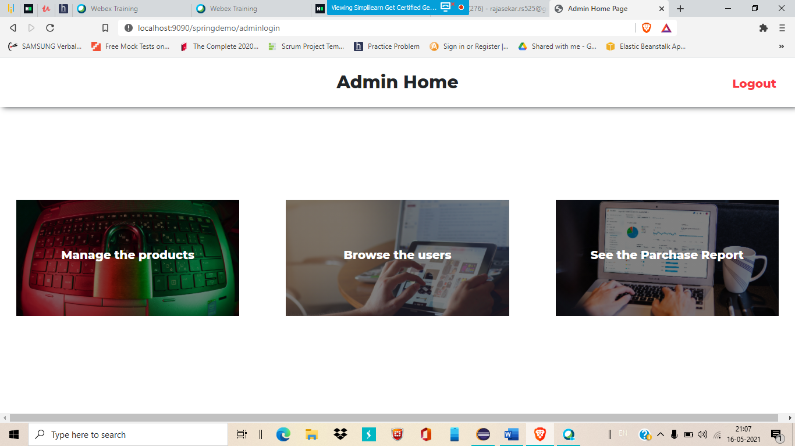

**18.Click on Manage the product option**

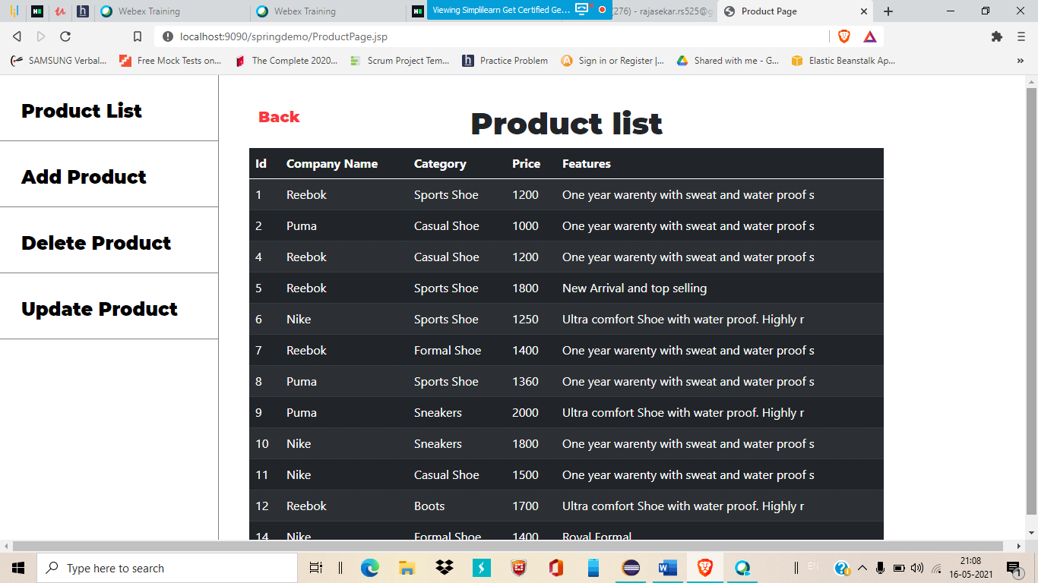

**19.In product list you can see all the products listed in the application**

**Click on add product to add new product in your web site**

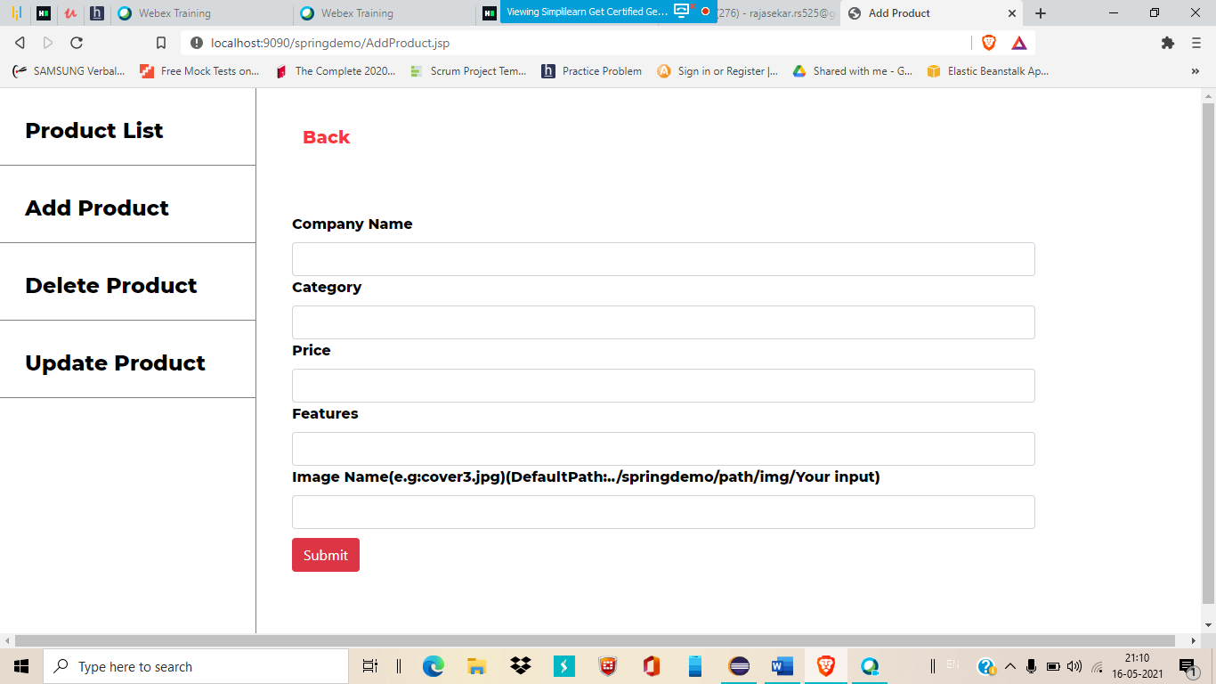

**20.Click on the particular product to delete it**

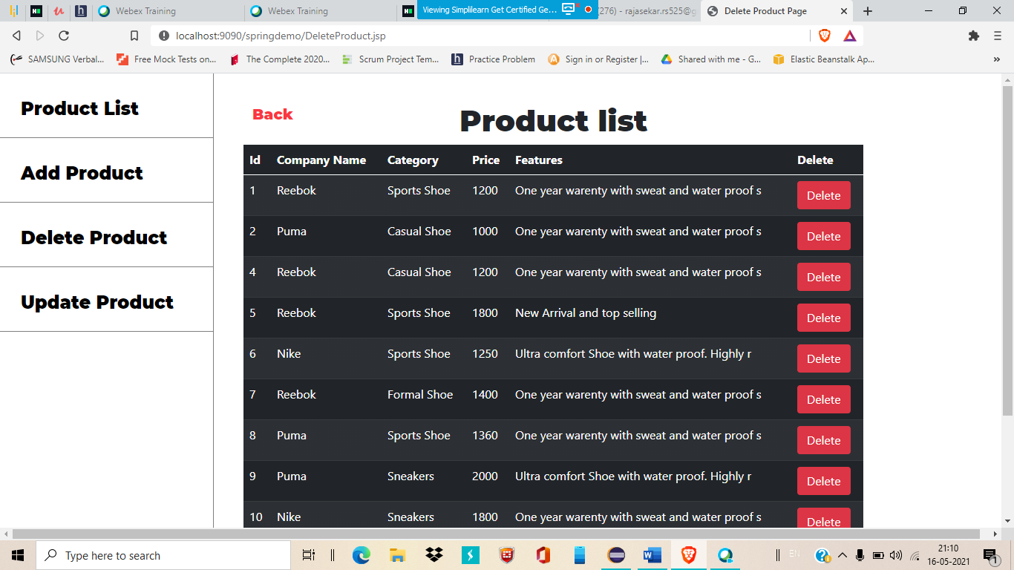

**21.Update product is for update the existing product**

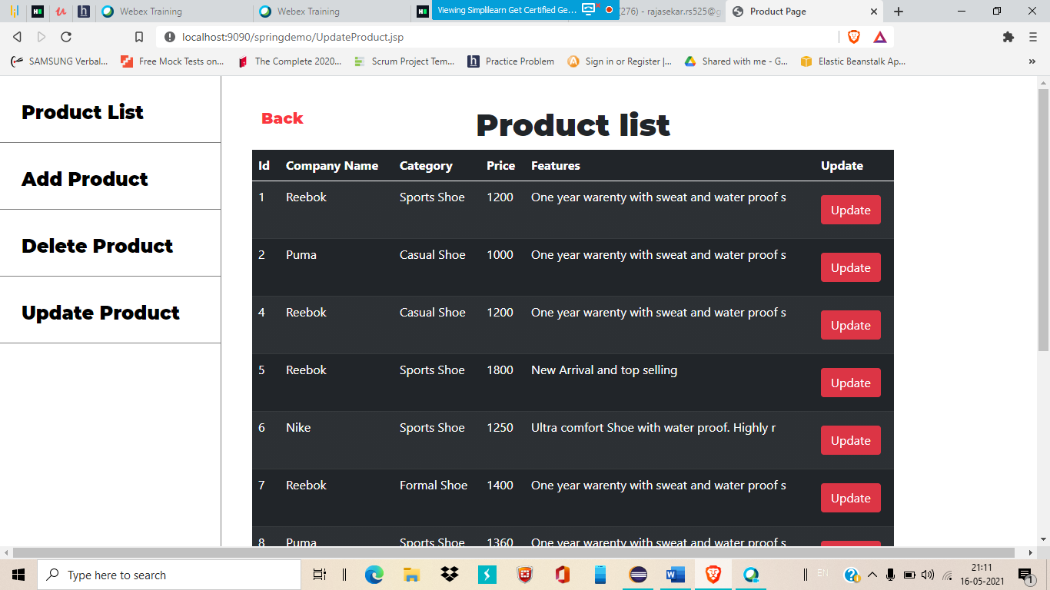

**22.Click on update to see this page**

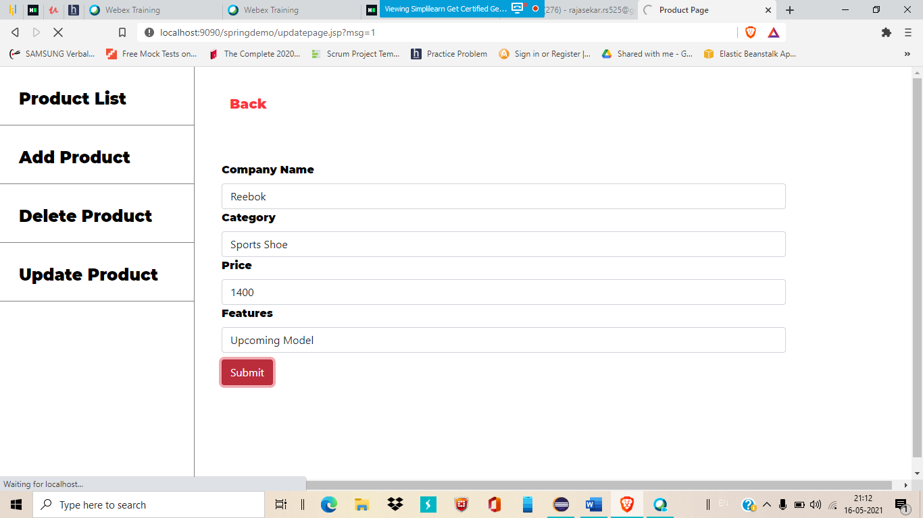

**23.Here you can see the updated content**

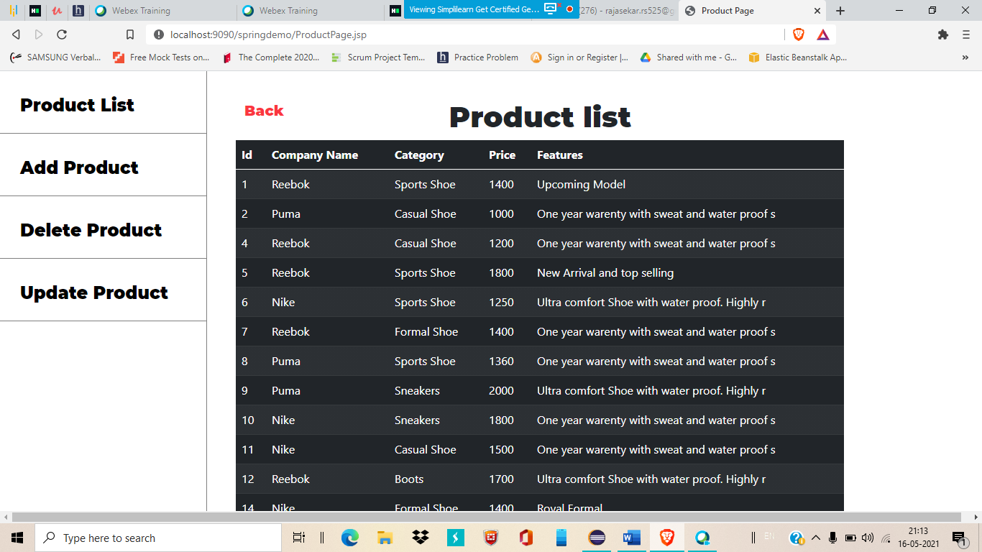

**24.Click on back option to return to Admin Home page again**

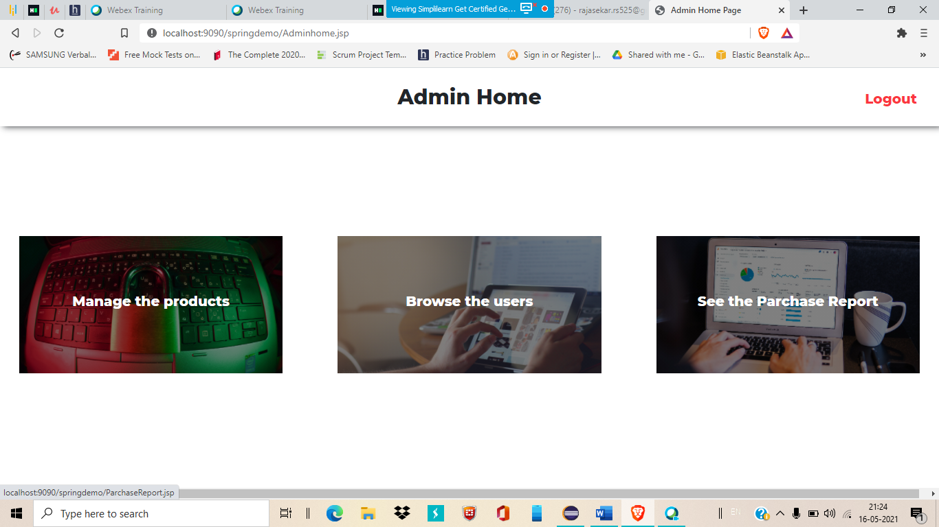

**25.Now click Browse the Users**

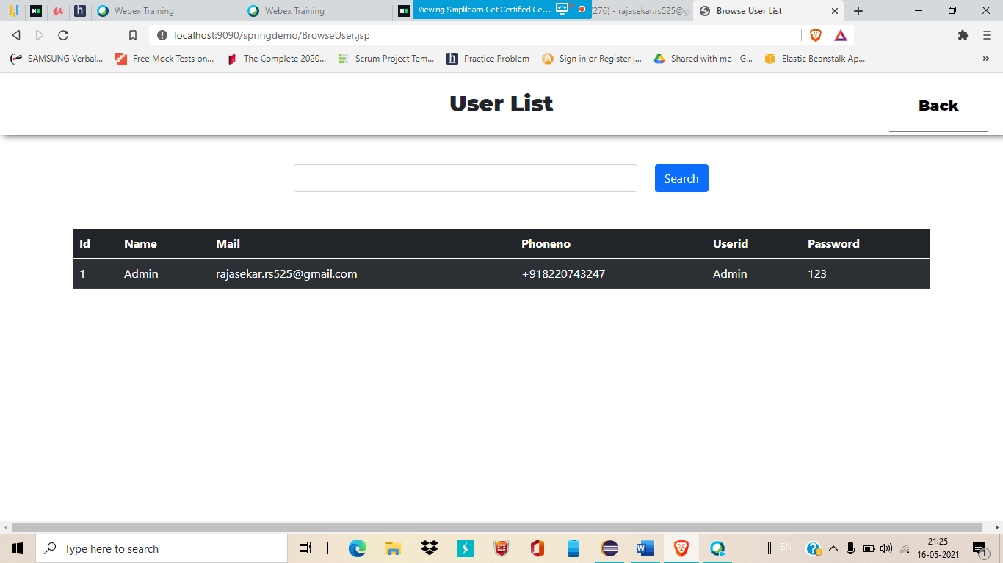

**26.Here you can able to see how many users were already signup/create an account and also able to filter the result by their Name using search bar option**

**27.Click on back button and go to Admin home page again**

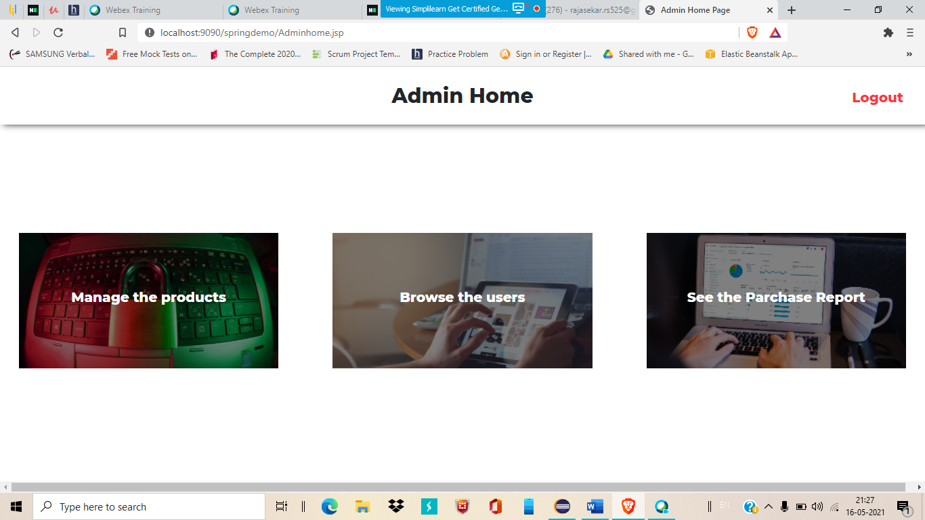

**28.Now select see the purchase report option**

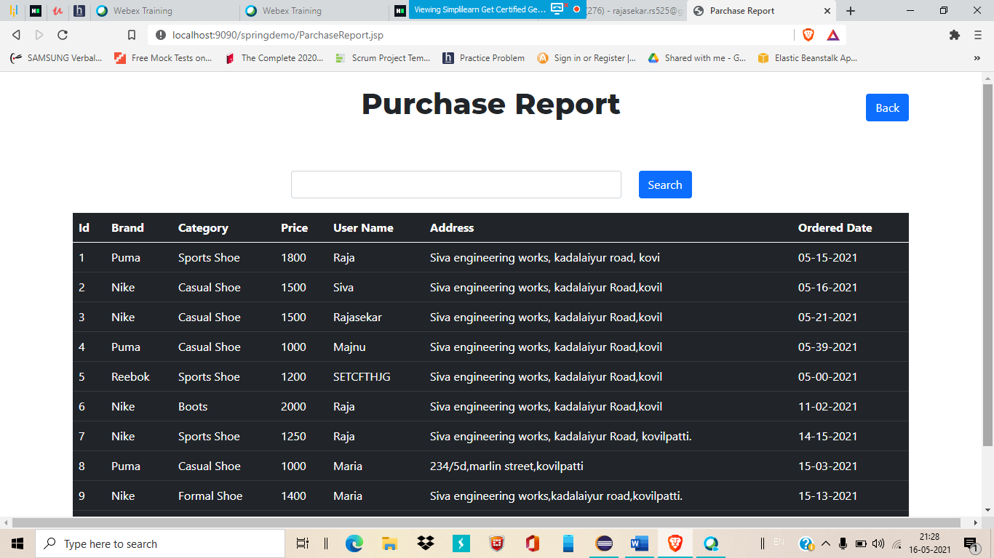

**29.You can filter a result by any (eg:Price,Brand,Category..etc)**

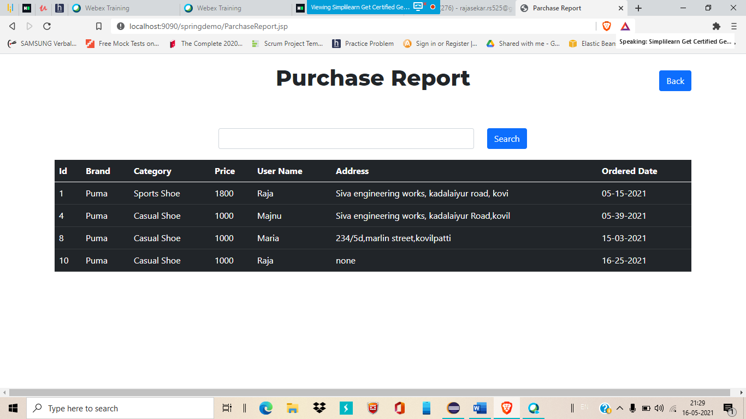

**30.Filtered by Brand: Puma**

**31.Empty search will return all the results**

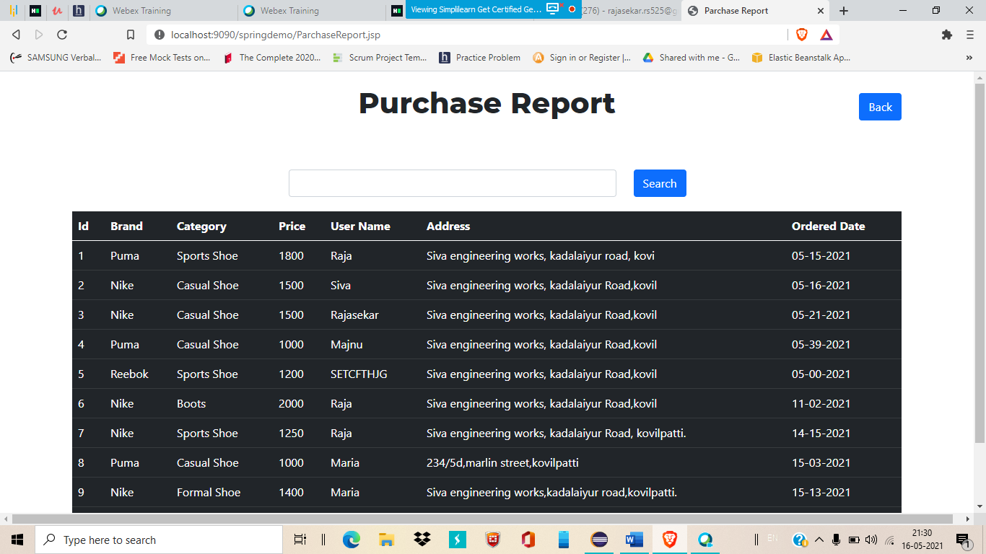

**32.Logout option is for out from the Admin page and return to home page**

